Baseball player Joe DiMaggio saw some publicity shots of Marilyn Monroe in March 1952 and decided to ask her for a date. Although she was a dazzlingly beautiful movie star, he was at that time by far the bigger celebrity.
His brilliance with a baseball bat for the New York Yankees made him one of America's most revered heroes. He had retired from baseball just a few months before, aged only 36, because of injuries - but the public adored him still as a sporting legend.
Iconic: Marilyn Monroe posed for this sexy, skirt-flying shot for The Seven Year Itch but husband Joe DiMaggio was incensed with jealousy and beat her
The date was set for March 8, at Villa Nova, an Italian restaurant which is now The Rainbow Bar And Grill on Sunset Boulevard. Marilyn, who wasn't sure she was much interested in a baseball player, was late by two hours.
But he impressed her. Despite his quiet, almost sullen demeanour, he still managed to command the whole room. He wasn't goodlooking: his face was all sharp angles, with teeth not only bucked but haphazardly arranged, and eyes too close together.
He was lanky and spindly. He didn't walk, he lumbered. But power seemed to emanate from him. After dinner, they drove around Beverly Hills for three hours, fascinated by each other.
During the summer of 1952, Marilyn and DiMaggio began to date more regularly. But red flags were raised by her concerned friends. He didn't like her career, he thought women should be firmly in the home, he was jealous of the attention she generated from other men.
In July, Joe took her home to San Francisco to meet his family. Once there, she clearly saw why Joe wanted his wife to be domestic - women raised children, cooked and cleaned, and it had always been that way in the DiMaggio family.
The eighth of nine children of Sicilian immigrants, Joe was raised with strict Catholic values in a household that stressed a strong work ethic and, above all, pride in their Sicilian heritage.
At the end of summer, Joe dropped a real bombshell: he thought it would be best if Marilyn abandoned her acting. It only caused her stress, he argued, so why do it?
'Joe was sick and tired of Marilyn's career,' said Stacy Edwards, who was a sportswriter at the time in Philadelphia and knew DiMaggio well. 'He said he wanted to get her out of the movies. "We'll buy a nice home in San Francisco and just live a simpler life," he told me.
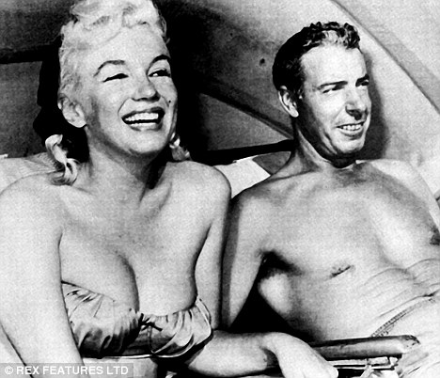
'I knew Joe and I knew what he was about deep down, and it wasn't just Marilyn's career. The attention she got, he was used to getting. When he walked into a room with her, he disappeared. He wasn't used to that at all. He was used to being centre of attention. But with Marilyn, no man could ever be centre of attention. Joe couldn't accept that.'
Then, on New Year's Eve 1953, Joe asked her to marry him. Carried away by the moment, Marilyn said yes. On January 14, 1954, they were married in a quick civil ceremony in San Francisco.
She made a strange request though. If she died before him, would he promise to place flowers at her grave every week? He promised - and years later would fulfil this bleak pledge.
Even with his ring on her finger, DiMaggio could not reconcile himself to Monroe's stardom. He turned to his friend Norman Brokaw, a Hollywood agent, for advice. 'I want her to quit,' he told him, 'but she won't do it.'
Norman mulled over his friend's problem for a moment and said: 'Joe, let me explain something to you, as an agent in this town. There's no actress in this business who is going to give up Clark Gable or Tyrone Power or Spencer Tracy for any man.
'In fact, I don't know any actress who'd be willing to give up her career when she's on her way to the top, any more than you'd have given up your baseball career before its time. So you have to get used to it. Or, honest to God, you're going to lose her.'
Not long after this meeting with Norman, Joe wrote in his personal journal about Marilyn: 'No jealousy . . . Don't forget how lonesome and unhappy you are - especially without her.'
But the jealousy wasn't the only problem. 'He was smacking her around,' said one of his closest friends. 'He didn't seem too ashamed of it, either. He said that she brought the worst out in him, that he wasn't usually that kind of man. He said she was spoiled and very self-centred and it drove him crazy.'
The final straw for Marilyn came when Joe beat her up in their hotel after he became incensed at the sexy, skirt-flying shoot for The Seven Year Itch.
Five thousand onlookers watched the filming of that shot, at one in the morning, with Marilyn standing over a subway grate, her accordion-pleated skirt flying. Unfortunately, DiMaggio was one of them.
Director Billy Wilder described the expression on DiMaggio's face as 'the look of death'. Even though Marilyn wore two pairs of pants for modesty, under the powerful Klieg lights the material became quite see-through.
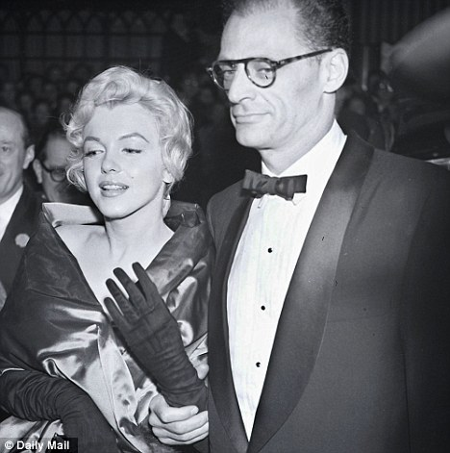
Unhappy marriage number two: Marilyn was always afraid playwright husband Arthur Miller, would 'find out' she wasn't intelligent enough for him
He rushed back to their hotel and waited for his wife. Then he took out his rage on her, slapping her around the room. The noise was so great that other hotel guests reported it to the hotel's management, afraid that someone was getting badly hurt.
The next day, Gladys Witten, a studio hairdresser, noticed bruises on Marilyn's shoulders.
'But we covered them with make-up,' she said.
Sportswriter Stacy Edwards says: 'The way I heard it, Joe let her have it. It was pretty bad. After he hit her, she told him she'd had enough and wanted out of the marriage.
'I spoke to Joe maybe three weeks later and asked him about that night. He said "Things got out of hand, I admit it. But she p****d me off so much. She didn't care what I thought about anything, she just wanted to do what she wanted to do."
'I lost a lot of respect for Joe when I found out he hit Marilyn. I thought "How could any man hit such a beautiful creature?"'
On October 27, 1954, just nine months after her wedding - Marilyn stood before a judge and detailed her reasons for her divorce petition. She said DiMaggio was 'cold and indifferent' to her and that days would go by when he wouldn't speak to her. DiMaggio didn't make an appearance and the divorce was granted.
One of the people Marilyn could turn to during this time was her friend Frank Sinatra. While her divorce was being finalised, she went to live with Sinatra for a couple of weeks to recover emotionally.
Sinatra was miserable himself at this time, because of the slow erosion of his marriage to actress Ava Gardner, said to be the love of his life.
For a time, his relationship with Marilyn was platonic. That situation apparently changed early one morning when Sinatra went into the kitchen and found Marilyn standing in front of the open refrigerator, trying to decide between orange juice and grapefruit.
By the time Marilyn came to make Some Like It Hot, she was mired in extreme depression while the cast and crew thought she was incredibly unprofessional
She was naked. 'Oh, Frankie,' she said, feigning embarrassment, 'I didn't know you got up so early.'
'That was the end of anything platonic,' reported Sinatra's friend Jimmy Whiting. 'Actually, Frank had been going through this impotency trip at this time. The booze was completely ruining his sex life. He was getting too old to drink like that and then expect to perform in the sack. He was frustrated by it, because one thing Sinatra always prided himself on was his ability to satisfy a woman.'
Apparently, Marilyn cured Sinatra of his impotence, at least for a while.
'Frank said that Marilyn was like a shooting star,' observed actress Esther Williams, 'and you couldn't help but be fascinated by her journey. While you knew she was going to crash and burn, you didn't know how.'
The only reason Sinatra wouldn't allow himself to become more serious with her was because he was still racked with pain over Ava.
A few months later, in the spring of 1955, Marilyn began a relationship with the intellectual playwright Arthur Miller. He was married when he met Marilyn and lived on the East Coast with his wife and two children.
They secretly began dating. Miller loved how well Marilyn listened to him, the way she hung on his every word. One mutual friend of the couple put it best: 'She was all about listening and receiving and he was all about talking and sending. He lectured her constantly. She was mesmerised by him. She drank him in like a sponge.'
However, she was reluctant to marry him because she wasn't sure she was right for him. He could continue to dazzle her with his intelligence, but she confided in friends she didn't think she was intelligent enough for him. 'What will he do when I'm found out?' she fretted.
Yet, despite her doubts, on June 29, during a very quick private service, Marilyn and Miller were married in New York. They travelled together to London in the summer of 1956 where Marilyn would have the unhappy experience of filming The Prince And The Showgirl with Laurence Olivier.
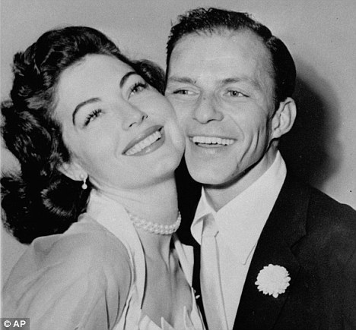
Lover: Frank Sinatra, pictured with actress wife Ava Gardner before they split, had a brief relationship with Marilyn
Mabel Whittington, a maid at the newlyweds' rented house, recalled: 'They seemed happy at the start, but as the months wore on he was constantly nagging her, usually how he felt she should prepare for the day's work. He picked on her a lot. She seemed to really want to know his opinion, though.
'However, I think there was a point when she'd had enough, especially when he began to criticise her acting when she was practising from her script. She'd walk around the house trying to remember a simple line, repeating it to herself over and over.
'He was annoyed and he kept correcting her. She snapped at him and said: "When you begin making pictures, we can discuss this. Until then, let me act and you do what you do."'
Shortly before filming was to begin, Marilyn happened to see a journal Arthur wrote, open on a table, and read it. What she saw terrified her.
On those pages, Arthur confessed he had second thoughts about having married her. She wasn't what he'd thought she was - she was just a child, not a woman. She wasn't as intelligent as he hoped and, in fact, she was someone he pitied. Moreover, he thought his career might be jeopardised by his new association with her.
He had heard that Laurence Olivier thought she might be a spoiled brat, and he didn't know how to respond to that, since he basically agreed. He called her a bitch.
It was the realisation of Marilyn's worst fear - that she would be 'found out', that she wasn't as smart or as talented as she had made him think she was, and now he knew the truth.
'It seemed to be raining the whole time,' Marilyn would say of her experience in England. 'Or maybe it was me.'
In July the following year, Marilyn learned she was pregnant. She wanted nothing more than to have a baby, but it was an ectopic pregnancy and she lost the baby. For the following year she was deeply depressed. By the time she came to make perhaps her most famous film, Some Like It Hot, she was mired in extreme depression.
On September 12, 1958, after a long and emotional telephone conversation with Arthur, Marilyn took an overdose of sleeping pills - something she had done several times before. Had it not been for her drama coach, Paula Strasberg, coming to her rescue, she might have died.
Once Miller arrived in LA to be with her, he realised practically everyone connected with Some Like It Hot, from Billy Wilder down, found his wife incredibly unprofessional. Miller was embarrassed for her and for himself. He was angrier with her than ever.
'My feeling about Arthur Miller was that he was a little too resentful of his wife,' Wilder recalled. 'I wasn't married to her. I didn't have to be patient and loving. But he was her husband and I thought he could have been more understanding. I remember saying at the time: "Finally, I have met someone who resents Marilyn Monroe as much, if not more, than I do." '
To compound her misery, on December 16, 1958, Marilyn suffered a miscarriage and, after a series of operations, was told she would never be able to have children.
The marriage limped on during the filming of The Misfits - written by Miller and which, unknown to either of them, would be her last film.
'Marilyn and Arthur so loathed each other, I'm not sure how either of them got through this movie,' recalled make-up artist Allan Snyder. Yet again her hopes of a happy marriage were to end in the divorce courts.
It wouldn't be long before Marilyn was hospitalised with a breakdown. She turned, strangely, to Joe DiMaggio to rescue her. He'd been in therapy and although he could still be jealous and controlling, he proved a loyal and trusted friend, although both knew better than to risk remarrying.
During this time, Marilyn also rekindled her romance with Sinatra. 'He was in love with her, no doubt about it,' said Milt Ebbins, business partner to President Kennedy's brother-in-law, the actor Peter Lawford, and a good friend of Sinatra's.
Her problems with drink and drugs were almost too much for him, though. In September 1961, Marilyn joined Sinatra on his yacht for a four day cruise to Catalina Island. She drank plenty of champagne and the more she drank, the more disoriented and boisterous she became.
She also took plenty of the sleeping pills to which she was addicted. Sinatra became frustrated and embarrassed by her behaviour. One of his former associates recalled: 'Tell you the truth, Frank couldn't wait to get her off that boat. She was embarrassing him. He told me: "I swear to Christ, I am ready to throw her right off this goddamn boat."
'Instead, he called one of his assistants at the end of the trip and had her taken back to his place. He told me later that when he got home, she was sound asleep on the couch.
'He picked her up and moved her to the bedroom. He undressed her and put her under the covers where she slept soundly through the night. I asked Sinatra if he was going to stop seeing Marilyn and he said: "By now, I would have cut any other dame loose. But this one - I just can't do it."'
Perhaps what is most telling about this time in her life is that despite her terrible unhappiness, the photographs of Marilyn are the best of her career.
Photographer Douglas Kirkland, who took the famous pictures of her in November 1961, lying in bed covered in white silk, says the idea was hers.
'She sat beside me and put me at ease. I was young and didn't know how to ask her to pose for sexy images, but she simplified it, suggesting: "I should get into bed with nothing on but white silk." We discussed the details and she said she wanted Sinatra music and chilled Dom Perignon.'
She never looked lovelier than she does in those photographs.
How she was able to turn on the professional Marilyn Monroe, at the same time as she was so terribly troubled, remained a true mystery to her friends and associates. It was as if she only found true bliss in front of the camera as the perfect vision of herself. She certainly never found it with any man.
• Extracted from The Secret Life Of Marilyn Monroe by J. Randy Taraborrelli, published by Sidgwick & Jackson on September 18 at £18.99 ° 2009 J. Randy Taraborrelli. To order a copy (p&p free) for £17.10 call 0845 155 0720.

