SATIRE (from The Onion --Online Humor Magazine)

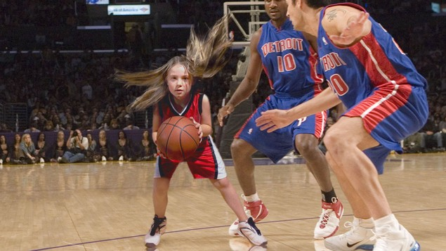 Pistons Lose To Elementary School Girls Team After Big Night From 4'9" Center

DETROIT—The woeful start to the Pistons’ season continued Thursday when dominant 4-foot, 9-inch center Shauna Thompson led the Thirkell Elementary School girls basketball team to an authoritative 88-72 victory over 1-8 Detroit.
The Pistons struggled all game long to answer the intimidating 84-pound fifth-grader, who forced her will upon the entire Detroit frontcourt to the tune of 54 points, 27 rebounds, and 14 blocked shots.
“Sometimes it’s simply a matter of having the best player on the court, and that’s exactly what that little girl was tonight,” Pistons coach Lawrence Frank told reporters after the game, adding that double teams made little difference against the aggressive, ponytailed 10-year-old. “I tried to tell my guys to just keep their hands up, but she used those pointy elbows of hers to clear space and went up over the top of us on almost every play. Nothing you can do to stop that.”
Most of Thirkell Elementary’s offense ran strictly through Thompson and point guard Megan Rivers, whom the Pistons struggled to keep up with because the fifth-grader can dribble with both hands and doesn’t have to look down at the ball to do so. On almost every possession, Rivers lobbed a high pass under the basket where only Thompson could reach it, allowing the nearly 5-foot-tall center to catch the ball and put up a shot from less than 5 feet away.
In the case of a miss, Thompson easily grabbed the rebound and put up another shot two or three times until she either scored or drew a foul.
“It’s hard to deal with a girl like that, one who’s clearly hit her first growth spurt and owns the paint on both ends of the court,” Pistons center Greg Monroe said. “And for her size she has impressive ball-handling skills and a great ability to dish out assists. Between her well-executed bounce passes and chest passes, it was really difficult for us to force turnovers.”
The 10-year-old phenom, who played 40 of 48 minutes, only offered the Pistons one real opportunity to take advantage of her absence from the game, when she sat out for five minutes in the second quarter to drink a juice box. Aside from that, it was Detroit who found themselves shuffling players through the frontcourt in hopes of finding anybody who could defend the “very cute, but very mean” Thompson.
“I’m not going to comment on whether she was too rough with Jason [Maxiell] and Greg [Monroe]—that’s for the league to determine,” said Frank, specifically pointing to a play in the second half in which Thompson made a strong move to the basket and knocked Maxiell down hard to the floor, requiring the power forward to seek medical attention for a sprained wrist. “Ultimately, our guys are fine. They were mostly just a little frazzled. She played kind of rough out there, but in the end we need to be able to handle players like that.”
The road doesn’t get any easier for the Pistons, as NBA analysts predict the team will struggle over the next week while traveling to play against a 65-plus YMCA league team from Columbus, OH, a wheelchair basketball team in Tampa Bay, and the Toronto Raptors.

Jessica Simpson Reveals Slimmer Figure After Chopping Off Limbs
NOVEMBER 20, 2012 | ISSUE 48•47 | MORE NEWS IN BRIEF
LOS ANGELES—Silencing gossip in the media about her weight, singer and actress Jessica Simpson wowed crowds this weekend when she stepped out in Beverly Hills with a trim new figure, flaunting her slender frame for the first time since chopping off all her limbs in October. “Gurl srsly looks ah-mazing!” Hollywood blogger Perez Hilton wrote under photographs of the starlet being wheeled into a shoe store, reportedly a whole 80 pounds lighter than she was last month. “Paps snapped our girl de-stressing with some retail therapy, and mama is looking fabulous with her slimmed-down frame! We are so proud of you, Jess!” When reached for comment, Simpson said the process of taking off the weight was “easy, fun, and the best thing I’ve ever done for myself.”

Mars Rover's Discoveries
After completing a difficult landing on the Martian surface last week, NASA’s car-sized rover Curiosity has begun deploying its highly advanced cameras and instruments, which will provide the most thorough data on the Red Planet yet. Here are several of its early discoveries:
- A few inches below the layer of dirt on the surface lies another, slightly thicker, layer of dirt
- Internet connection really slow
- Everything’s still pretty much the same as the last few times we landed rovers on Mars
- Vibe on planet really weird and off-putting
- Planet’s 24-hour-40-minute day provides perfect amount of extra time for light afternoon nap and crossword
- Previous Mars robots have formed a tribe
- After journey of hundreds of millions of miles and painstaking analysis of rocks and soil, found that the very best planet was at home all along
- It’s going to die out here alone on this cold red rock, isn’t it?
